1.Placed an order in stock

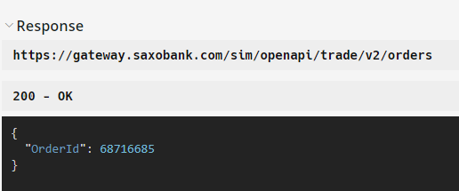

2.Use Order subscription on it so to be updated with the Order Status

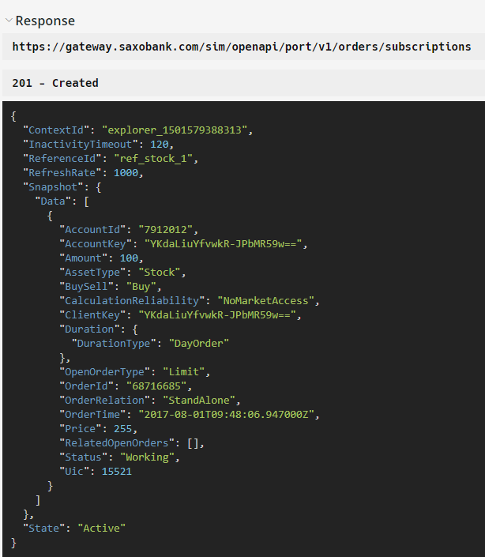

3.Use Position Subscription on it for Order Executed and position creation status.

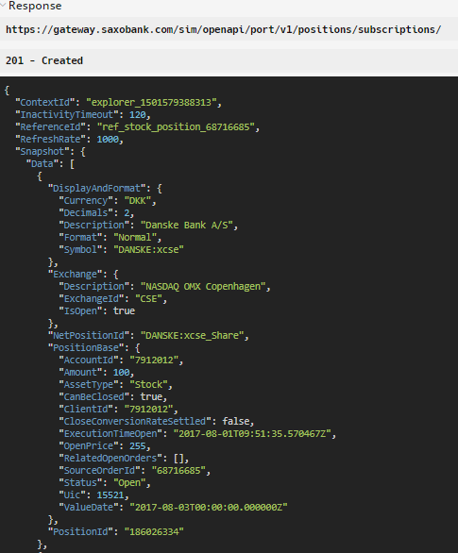

4. Use Order streaming Update in case of Cancelled/Expired state

2017-08-01T06:51:14.954Z:

[

  {

    "ReferenceId": "REF_ORDER_1",

    "Timestamp": "2017-08-01T06:51:14.705117Z",

    "Data": [

      {

        "__meta_deleted": true,

        "OrderId": "68716685"

      }

    ]

  }

]

5.Get the Audit activities to keep a track on the action performed

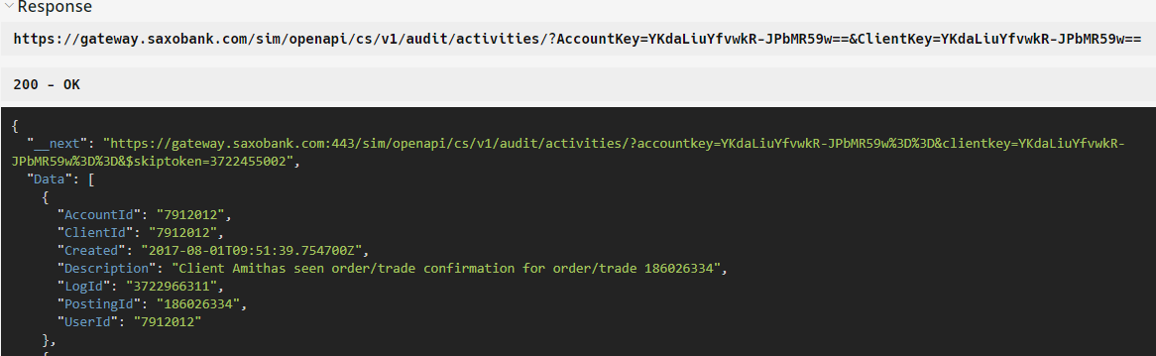

And Now based on above you can see how the order will flow from created -> working->Cancelled/Executed and you can use below information for your work:

* Use order state till the time order is in working state.
* Use Order streaming update value as>> "__meta_deleted": true along with the Order id when Order is in cancelled state.
* Once executed you should use position subscription (with source order id = order id) for tracking fill and order full execution.
* Audit activities does include the textual information under Description and it is not useful for maintaining status.